# C.V.RAMAN GLOBAL UNIVERSITY

BHUBANESWAR,ODISHA,INDIA



PROBLEM SOLVING WITH C

**TOPIC: CAR RENTAL SYSTEM**

SUBMITTED BY:-

NAME: **SHAKTI PRASAD**

REGD.NO:-**2201020413**

GROUP-7B

TEAM-6

BRANCH:-CSE(AI&ML)

**INDEX**

|  |  |  |
| --- | --- | --- |
| **SL. NO.** | **CONTENT** | **PAGE NO.** |
| 1 | Abstract | 3 |
| 2 | Introduction | 3 |
| 3 | Features | 4 |
| 4 | Conclusion | 4 |
| 5 | Source code | 5 |
| 6 | Output | 14 |
| 7 | Reference | 15 |

ABSTRACT:

This car rental system project would be useful for all the managements which give cars for rent as well as the people who travells a lot, Travel around the world. This system will make the rental system easy and convient for the user.

Many travelers take renting a car for granted especially during the pandemic when isolation is a priority. Customers prefer convenient and timely service, but it’s not uncommon for car rentals to lag. Roughly speaking, vehicle pick-ups delay [every third time](https://www.kmfiswriting.com/competition-results-in-record-breaking-rental-car-satisfaction-according-to-j-d-power/). Considering the tight competition in this business landscape, car rental services can’t fail to satisfy their customers.

INTRODUCTION:

A car rental management system is an autonomous system that will preserve the records of all the cars available, cars rented, etc. The user can rent a car based on its efficiency, performance, effort, or cost. The dealer can make a lot of use of this system by providing the cars. The public vehicle is not the best option. Public vehicles are crowded, generally not running on time e.g., trains, buses, etc. Here is our main problem to reach at own place on time with comfort. Thus, Car renting comes up with a solution. People who can’t afford a car. They can book a car for trip, marriage, business meeting, office to home, home to office, home to a market where ever they want to travel as simple as that.

FEATURES:

1.All proper keywords has been used to define is function this new system.

2.Basic concepts of C programming language like structures, array and files are used.

3.User will be able to get all details on how to use instruction on offline mode

4.It meets all the dealing out requests needed within system

CONCLUSION:

This Car Rental System project is designed to aid the car rental company to enable renting of cars through an online system. It helps the users to search for available cars view profile and book the cars for the time period. It has a user-friendly interface which helps the user to check for cars and rent them for the period specified. They could also make payment online. The rental cars shall be categorized into economy, premium etc. Based on the type of car required by the customer, the user shall be able to make bookings. The use of internet technology has made it easy for the customers to rent a car any time. This Car Rental System makes the bookings easy. It saves time and labor. The tool shall ask the user for information such as the date and time of journey, type of car etc. Also, it will need an identification number. Using these details, the tool shall help the customer to book a car for the journey.

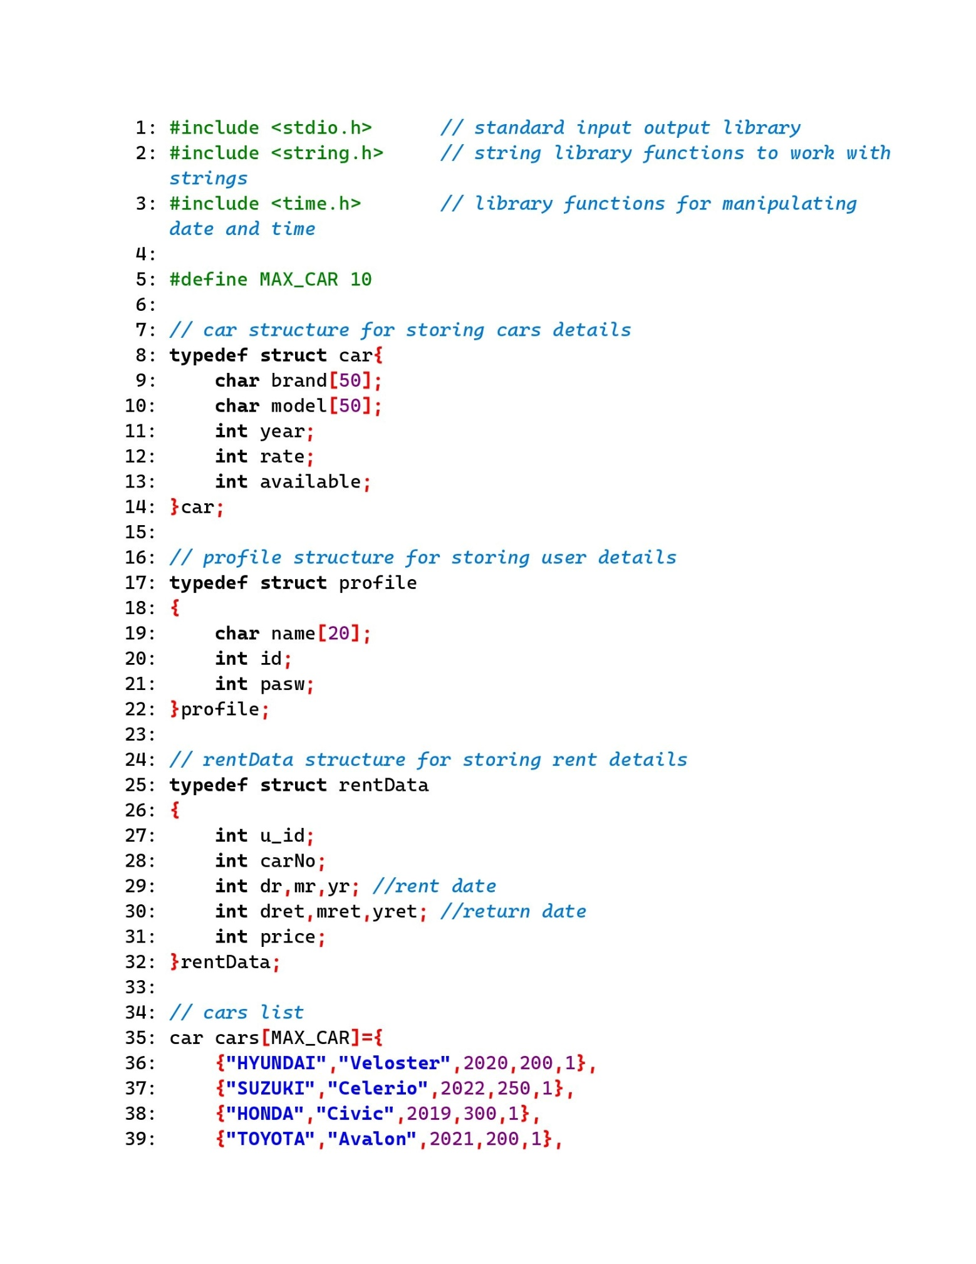SOURCE CODE

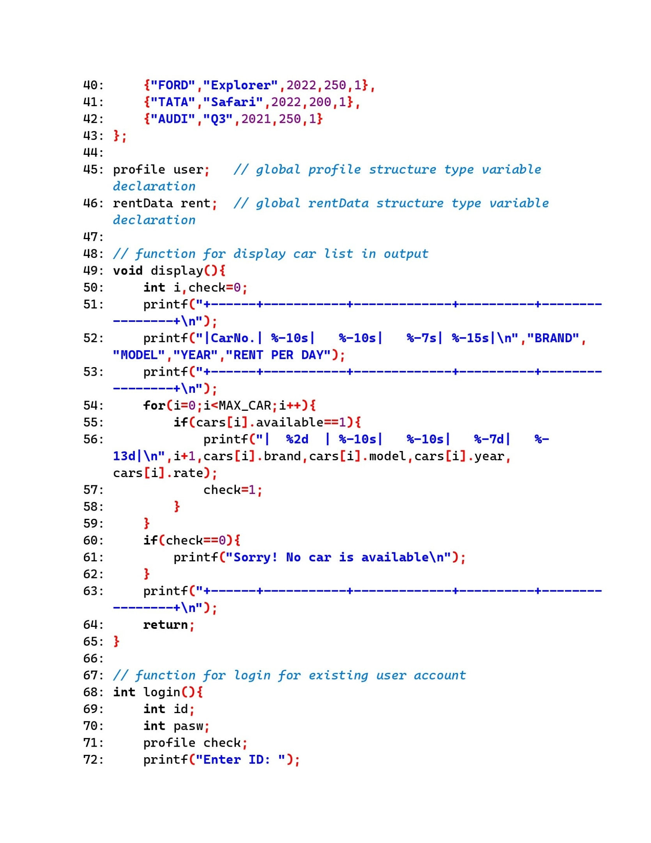

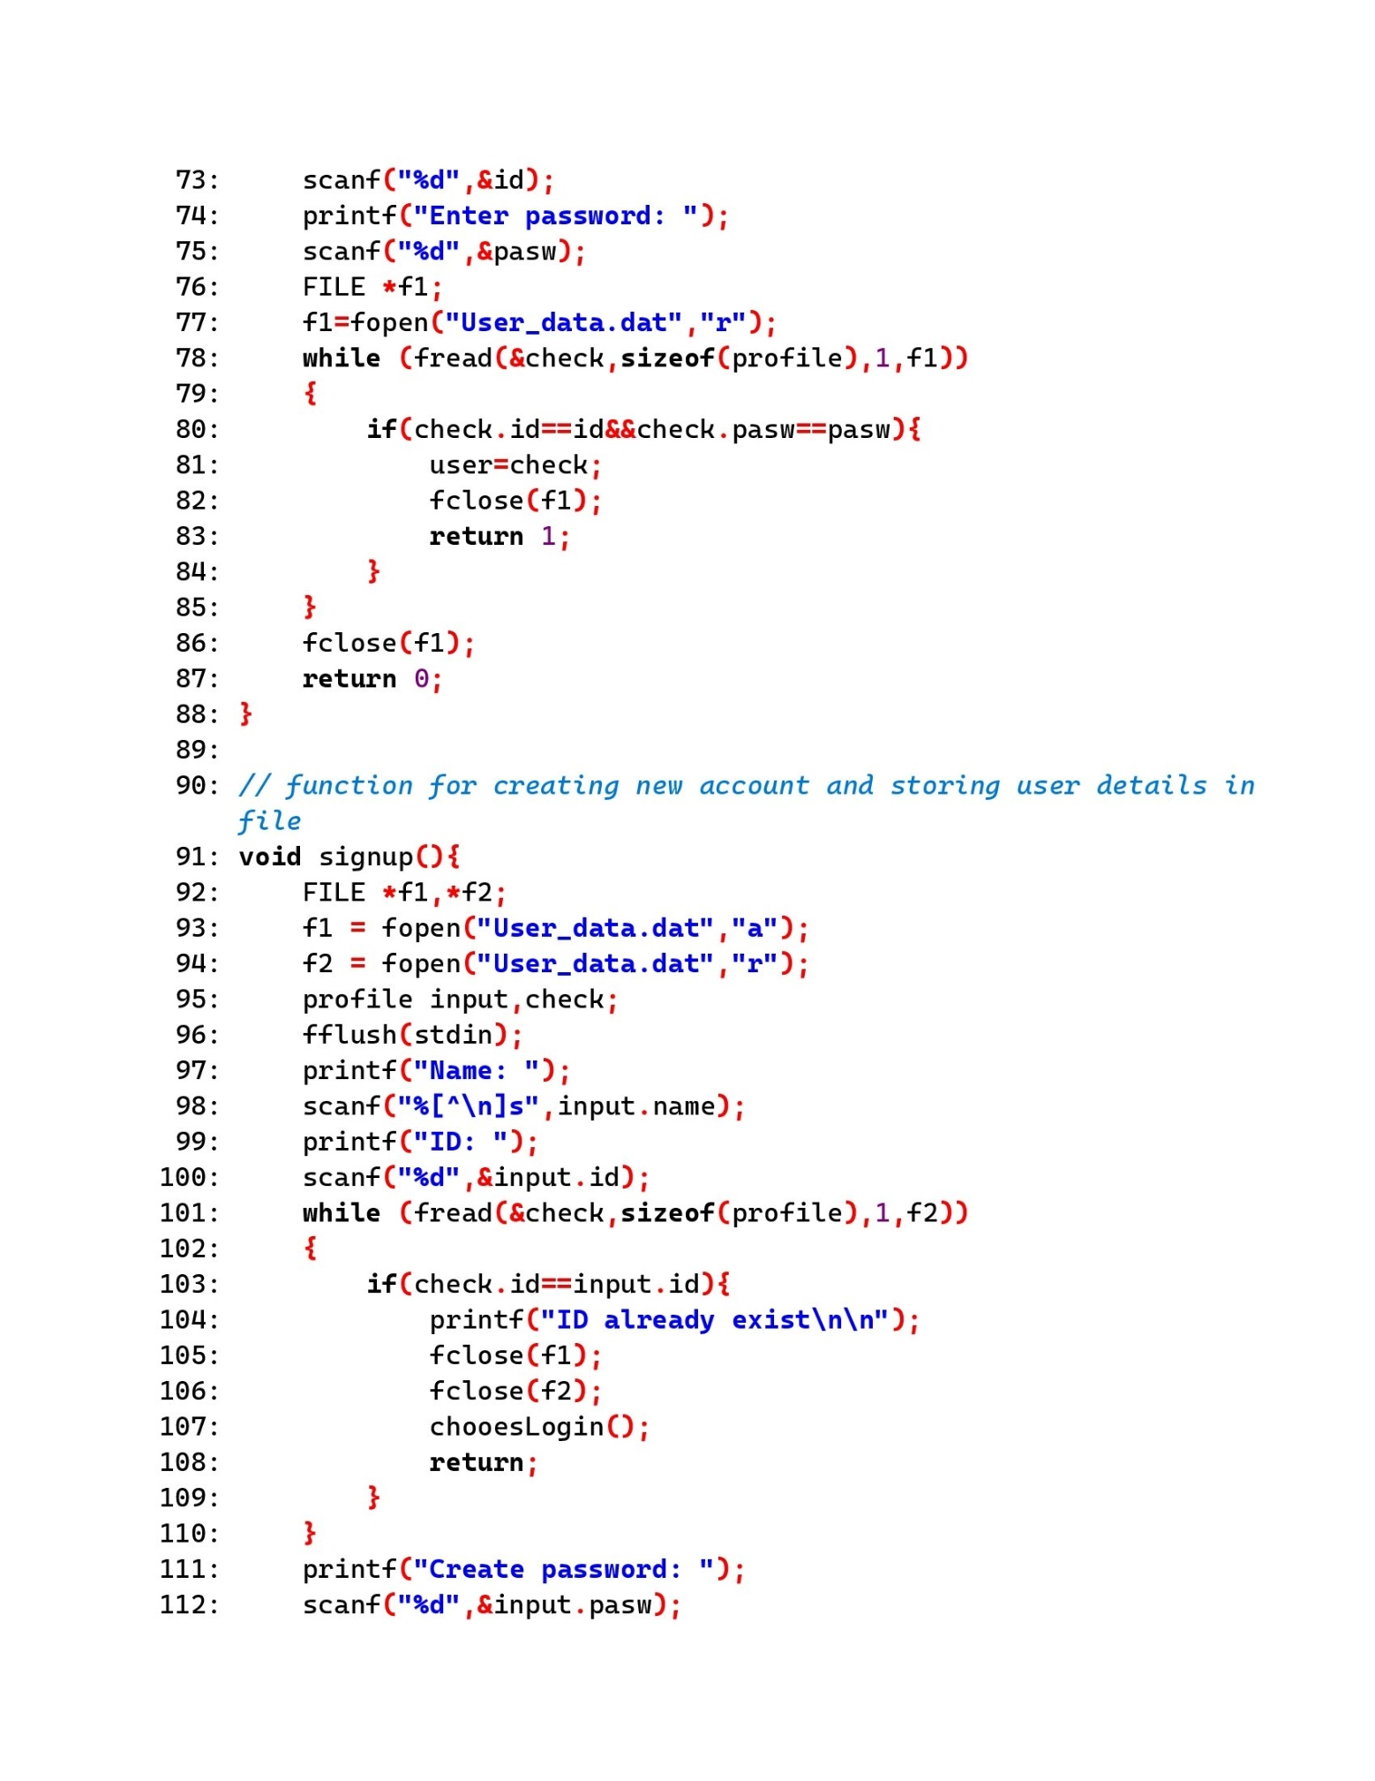

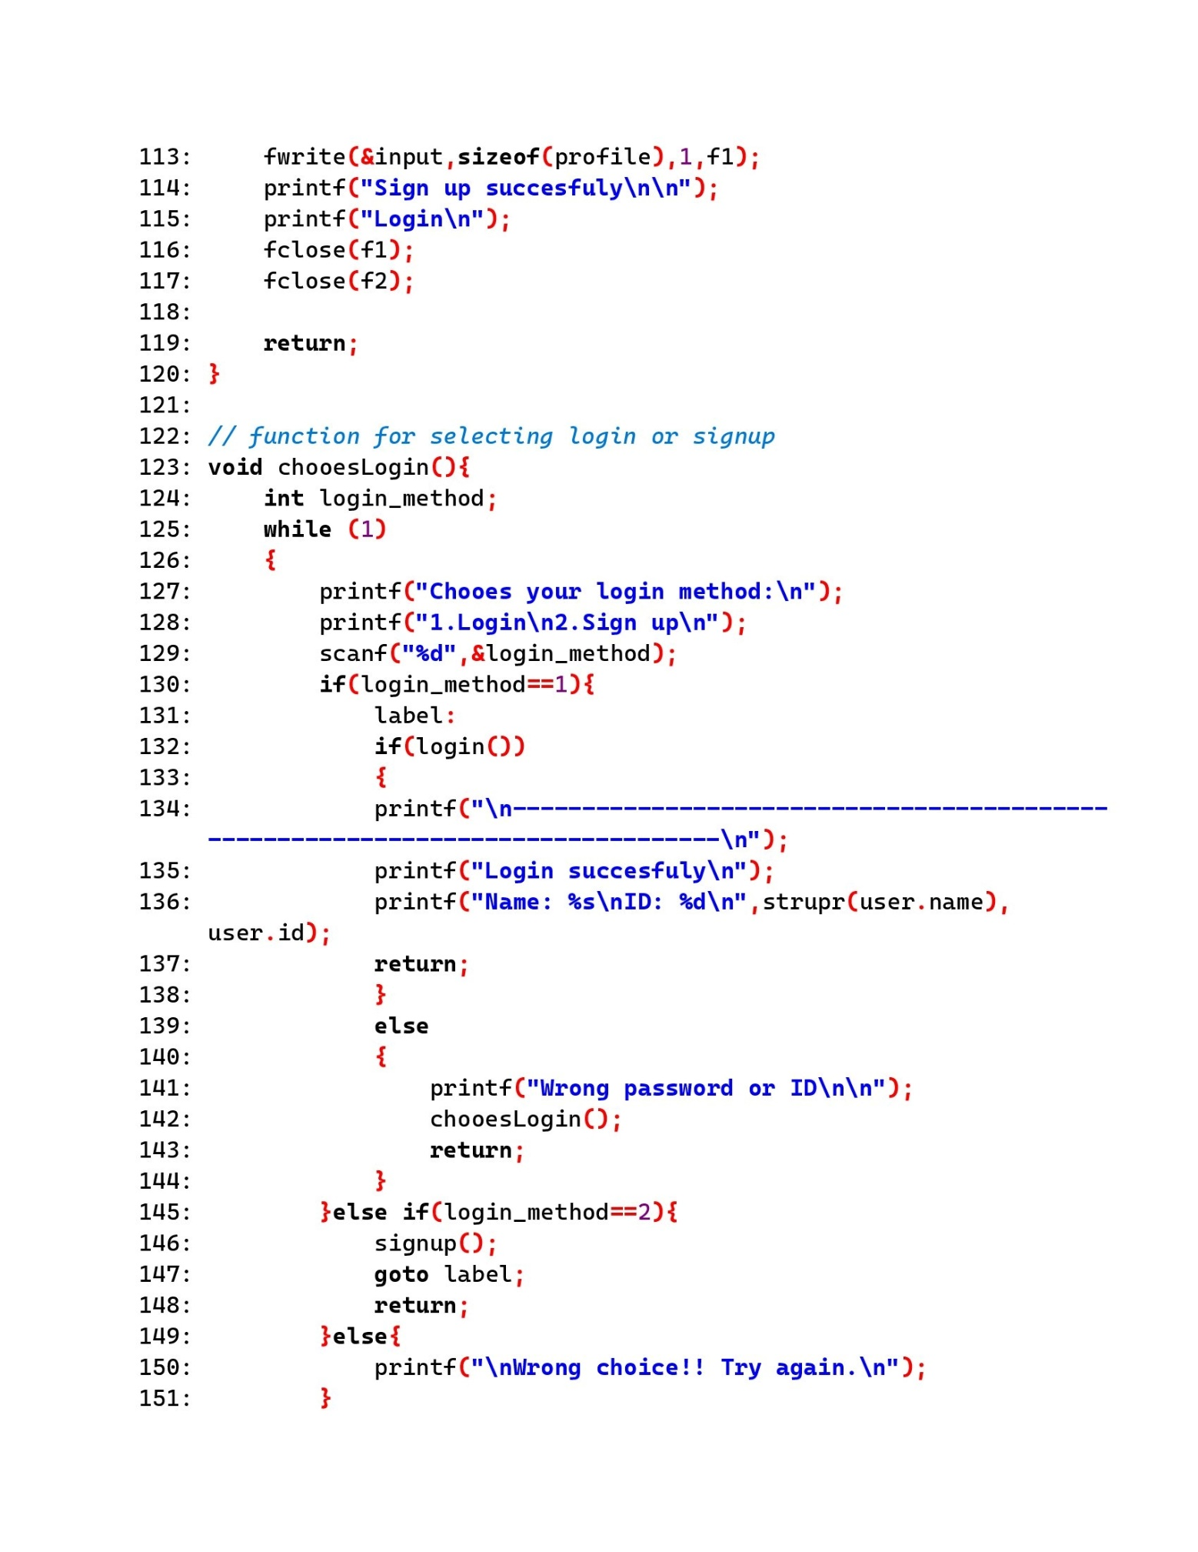

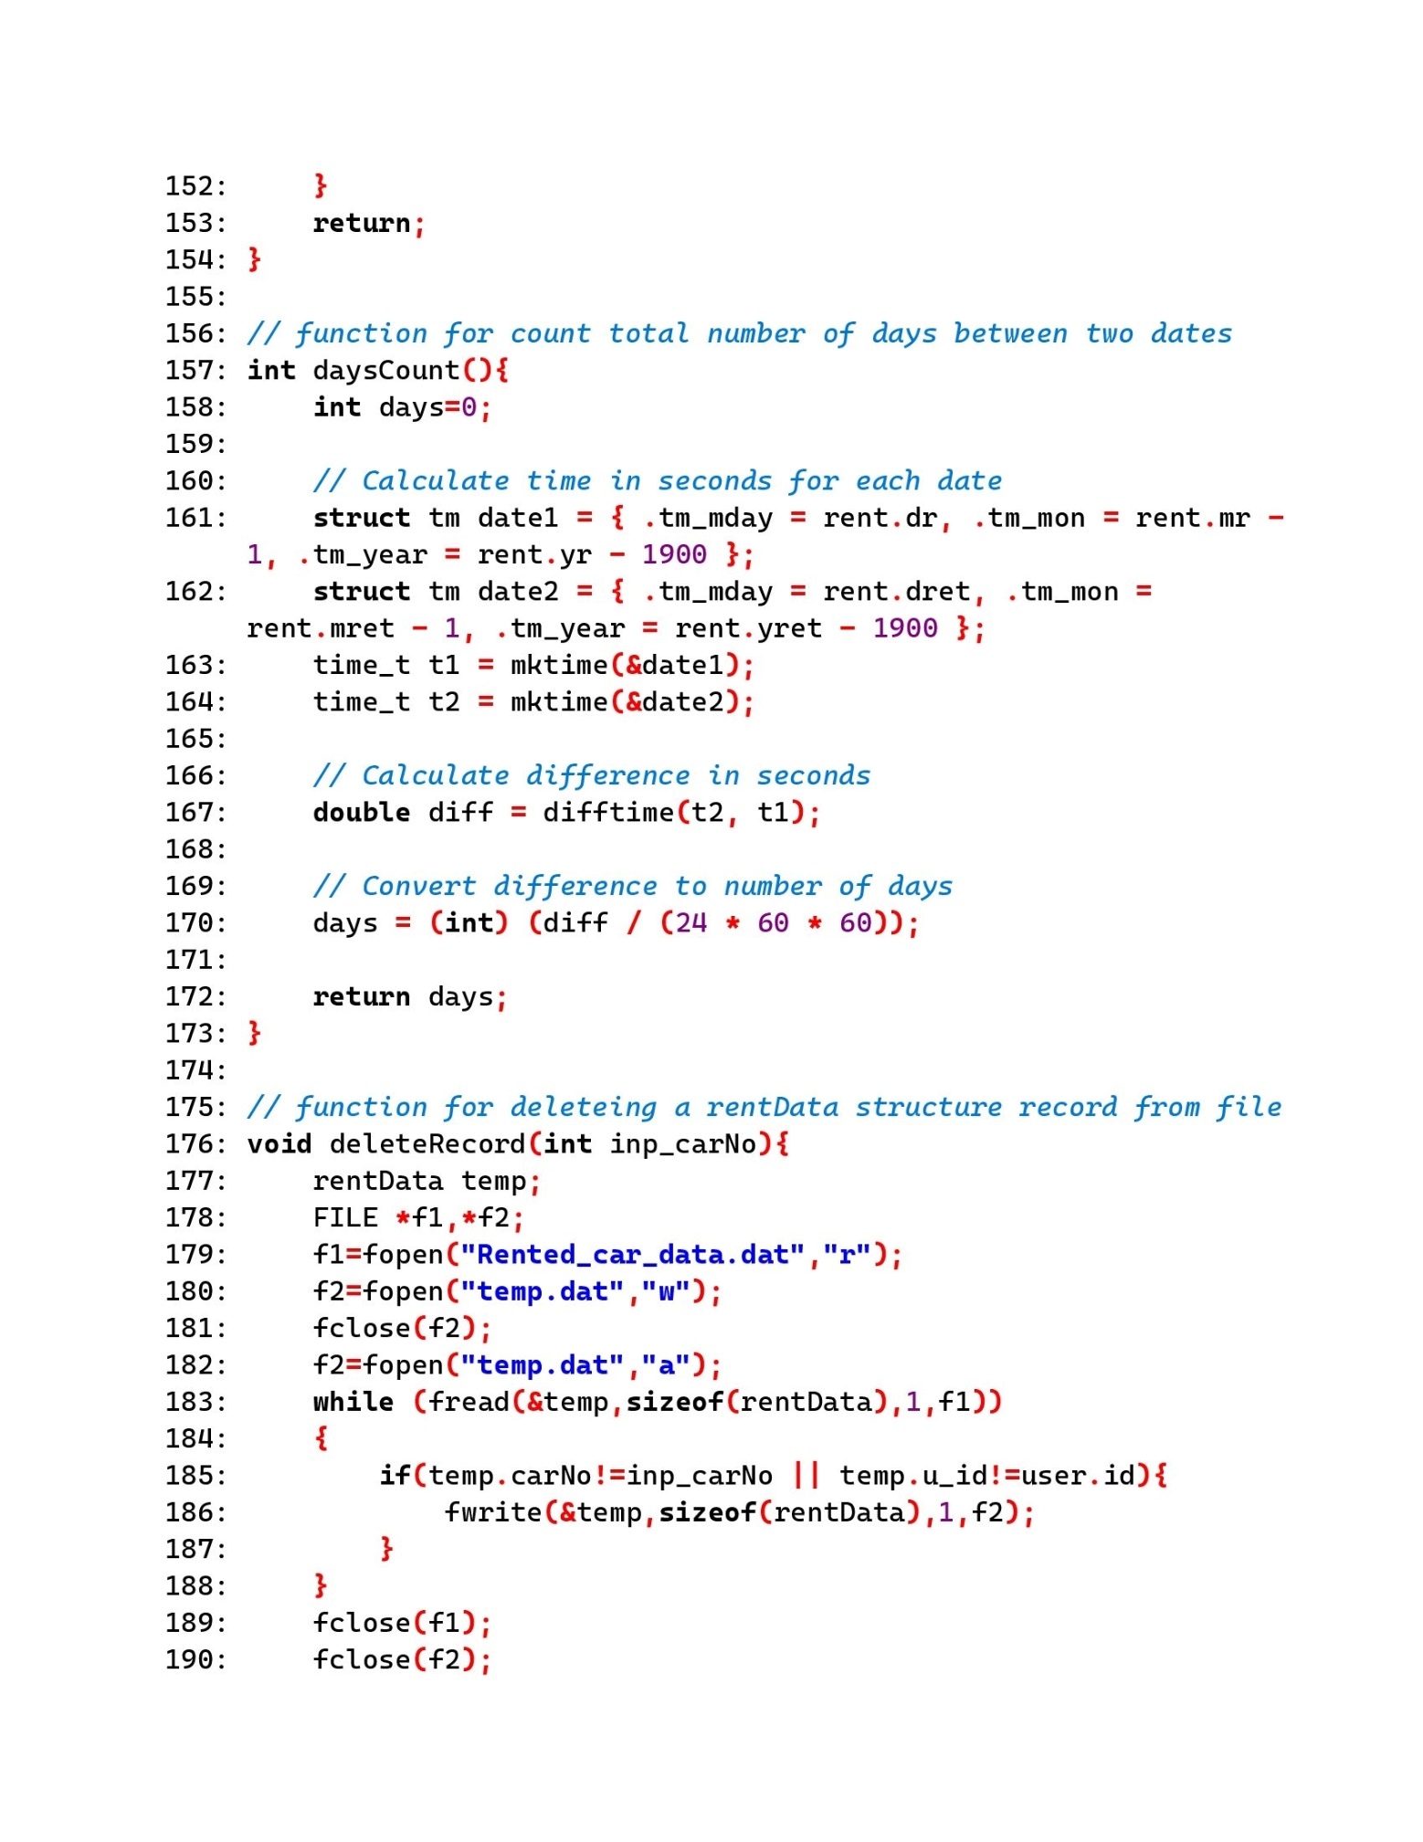

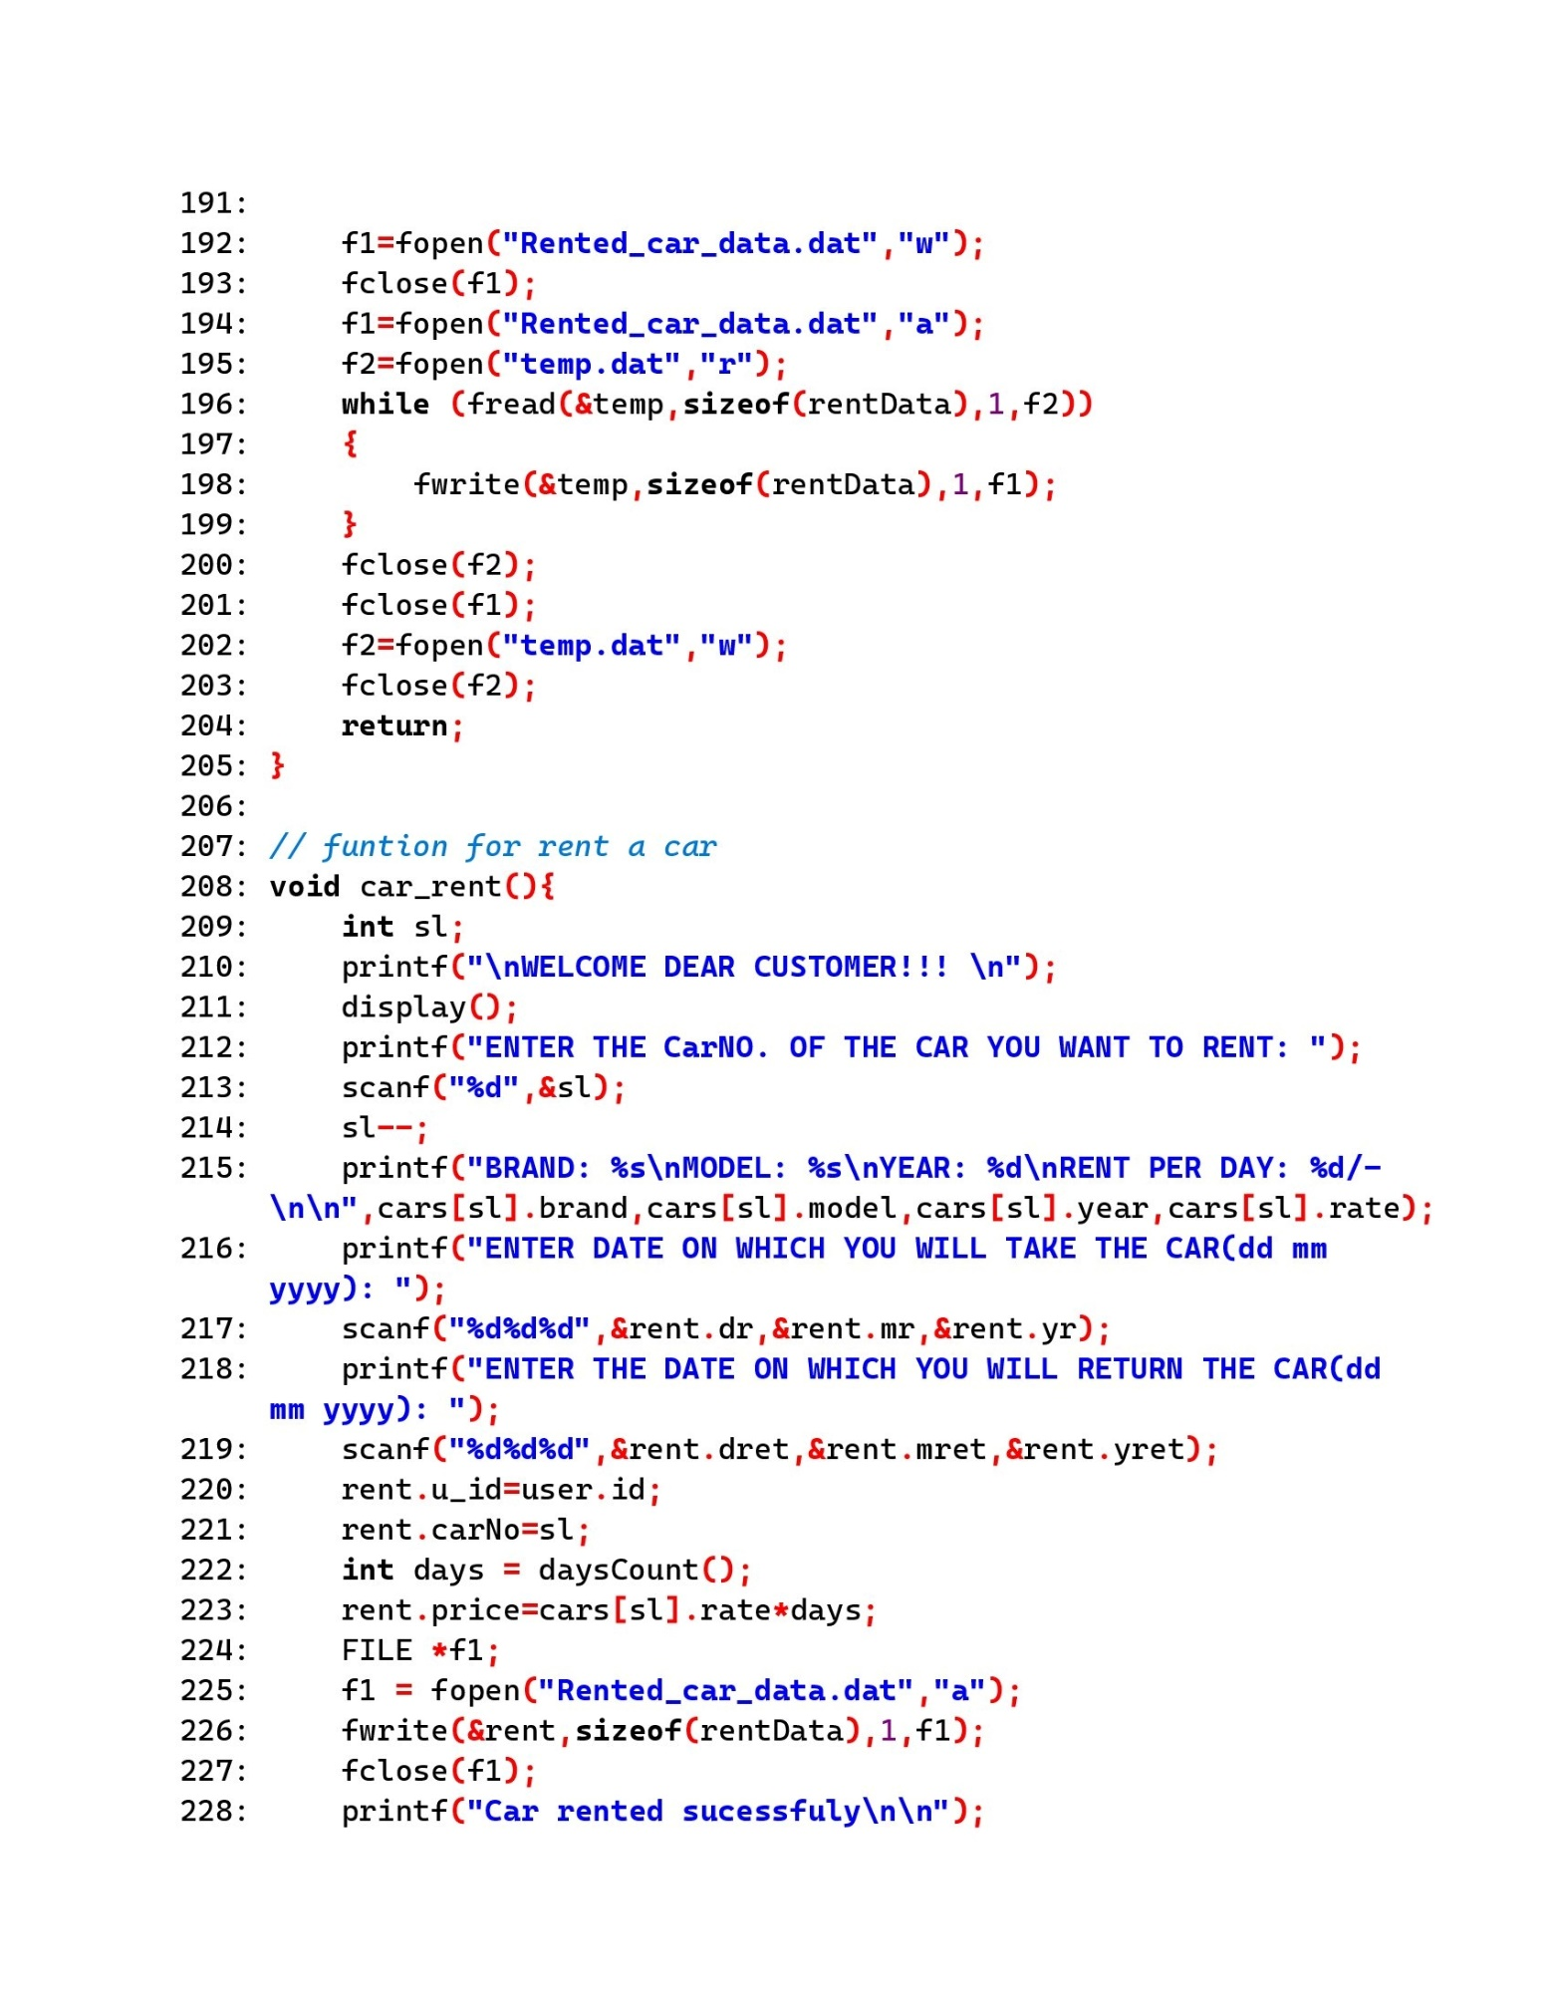

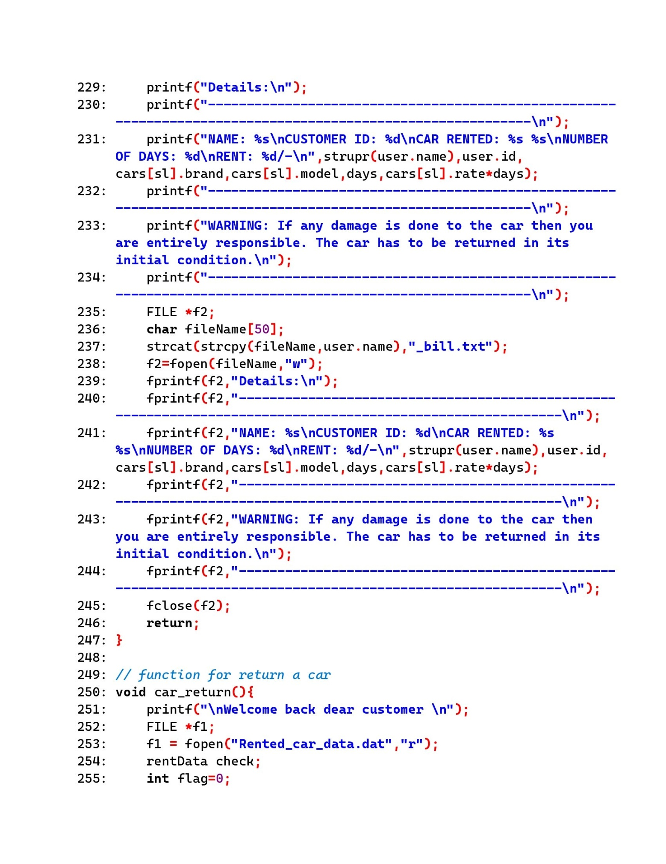

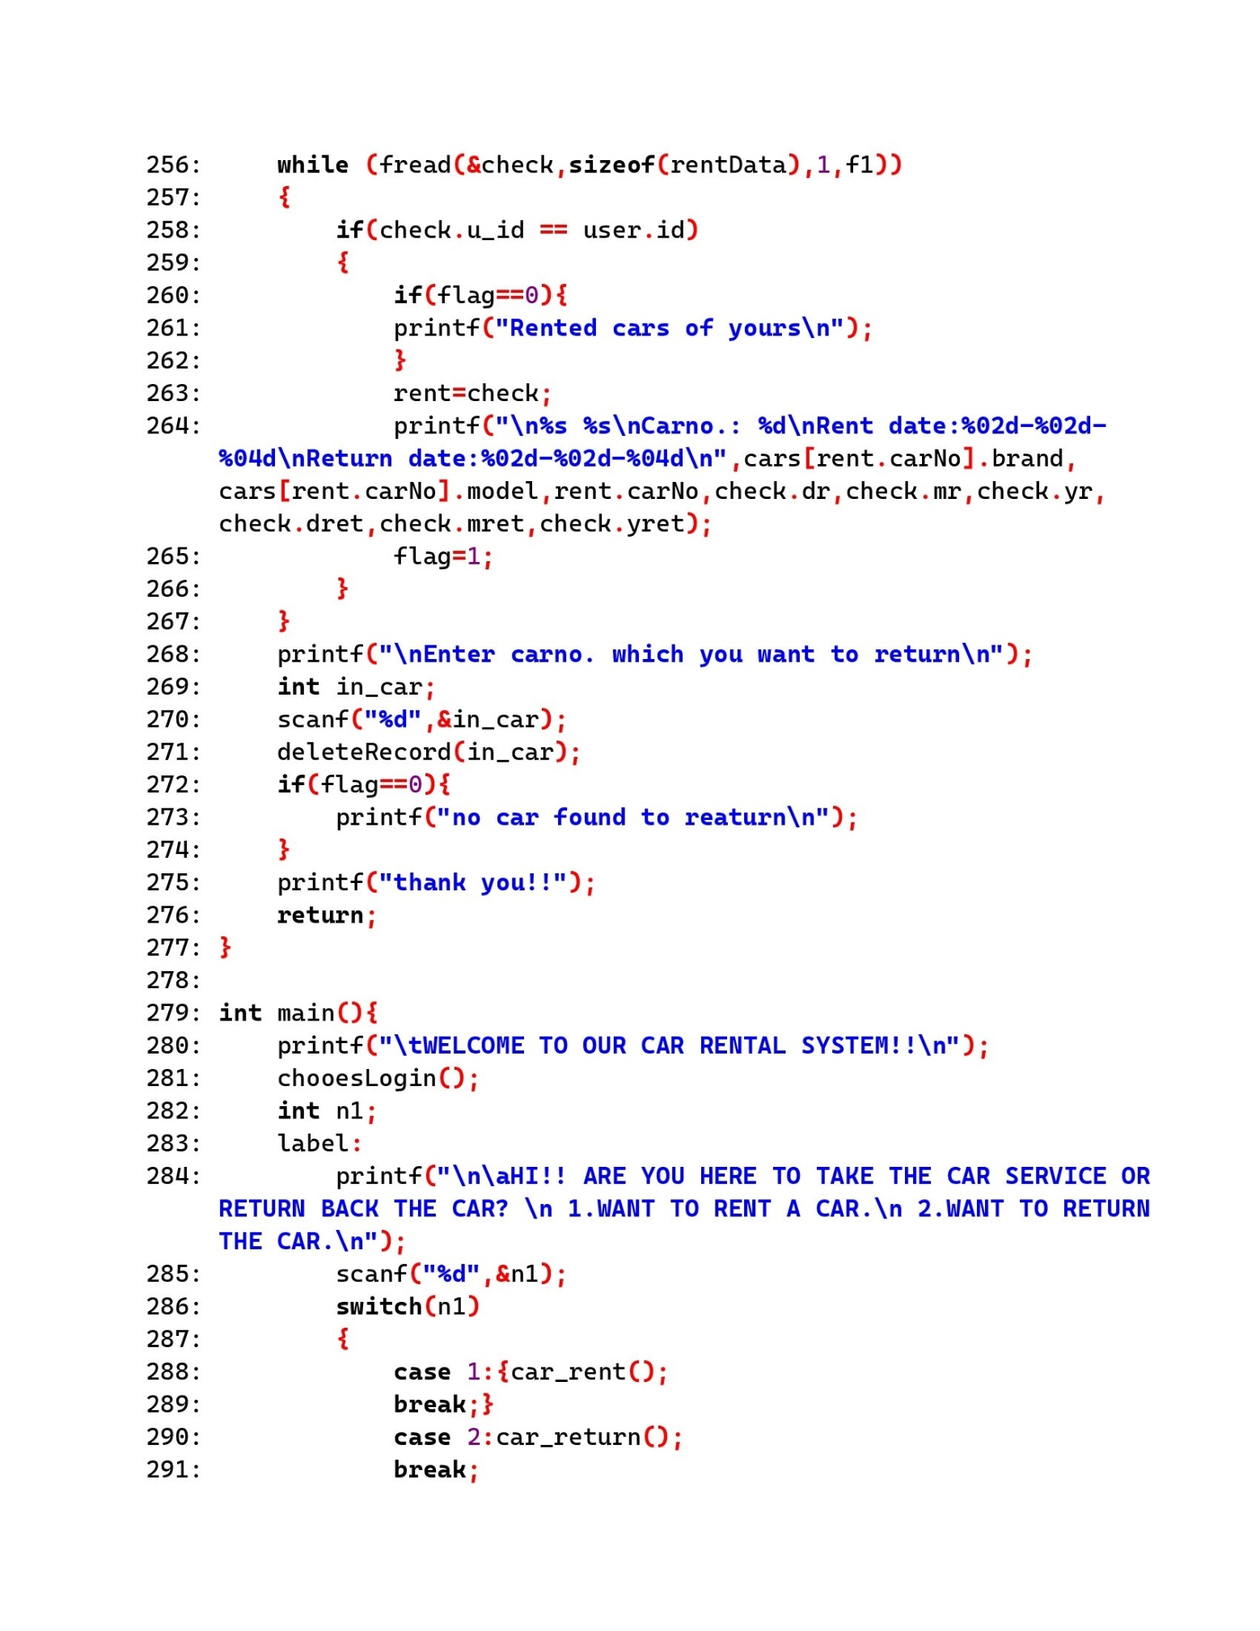

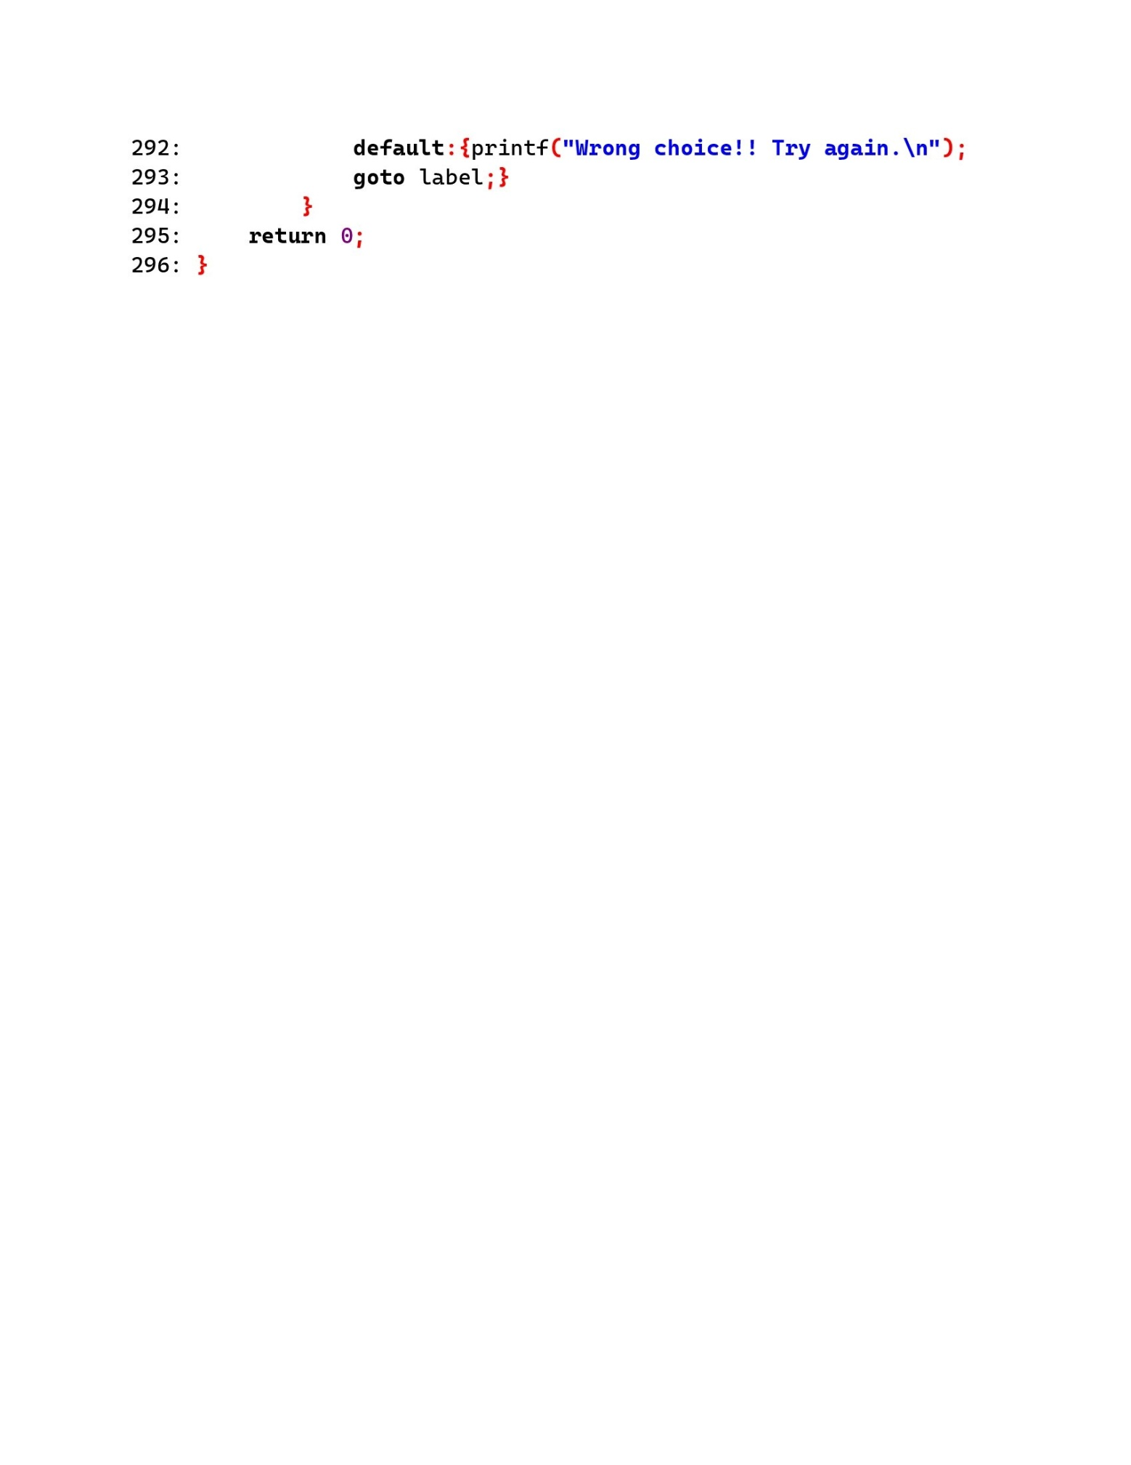

OUTPUT:

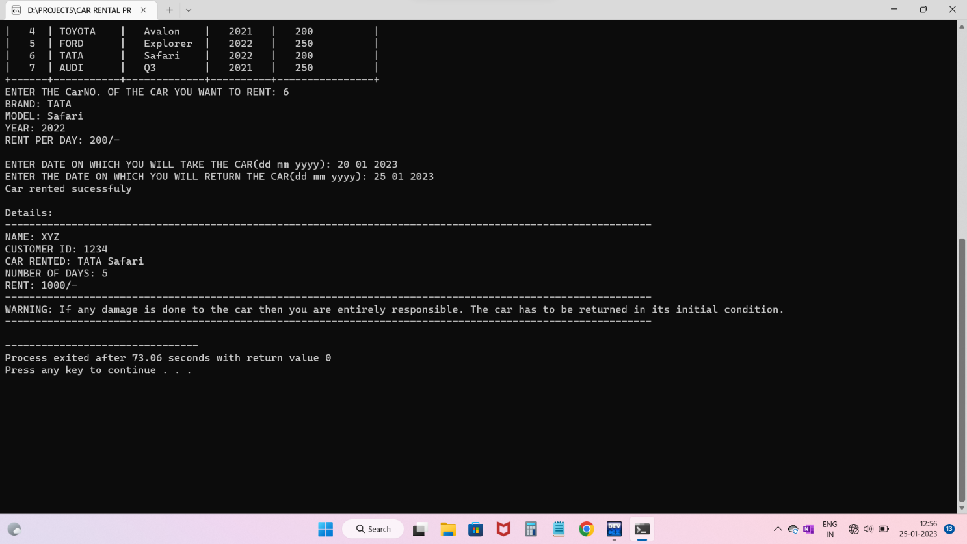

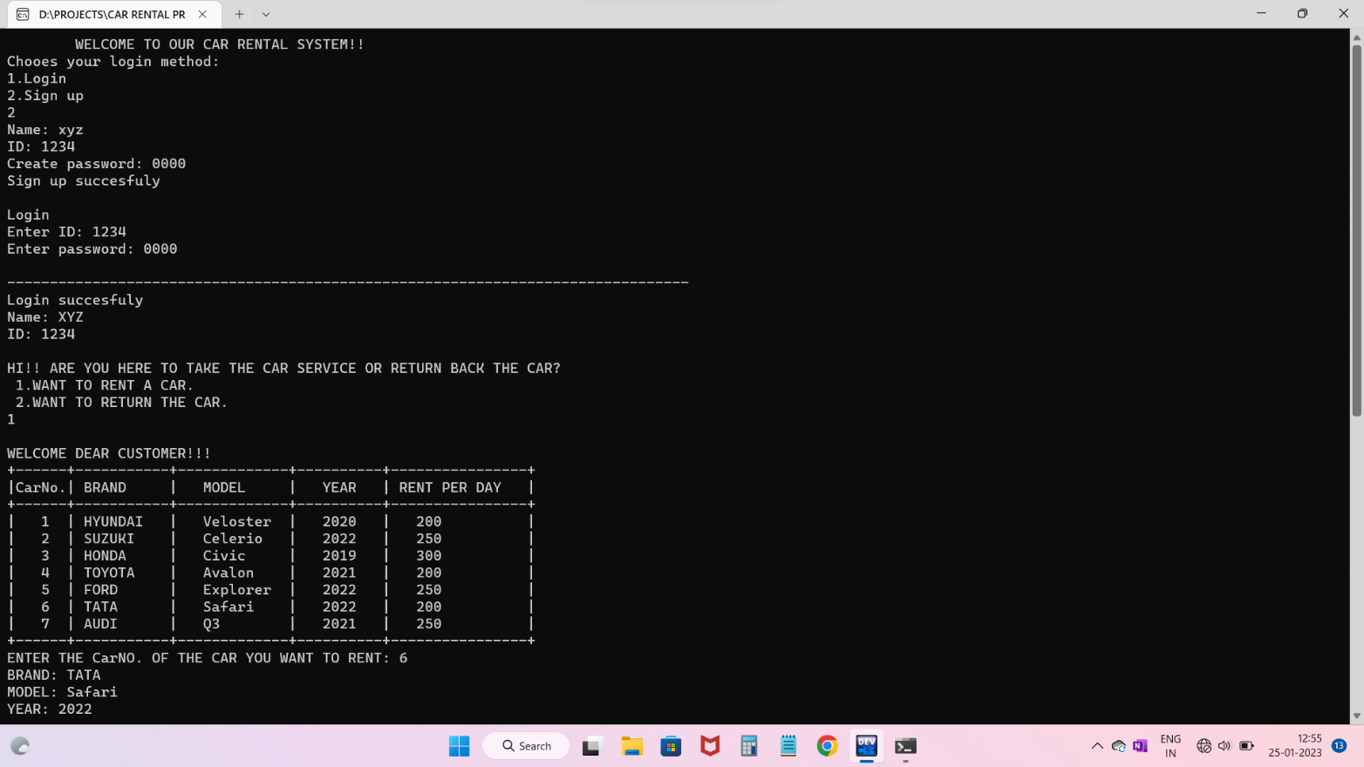

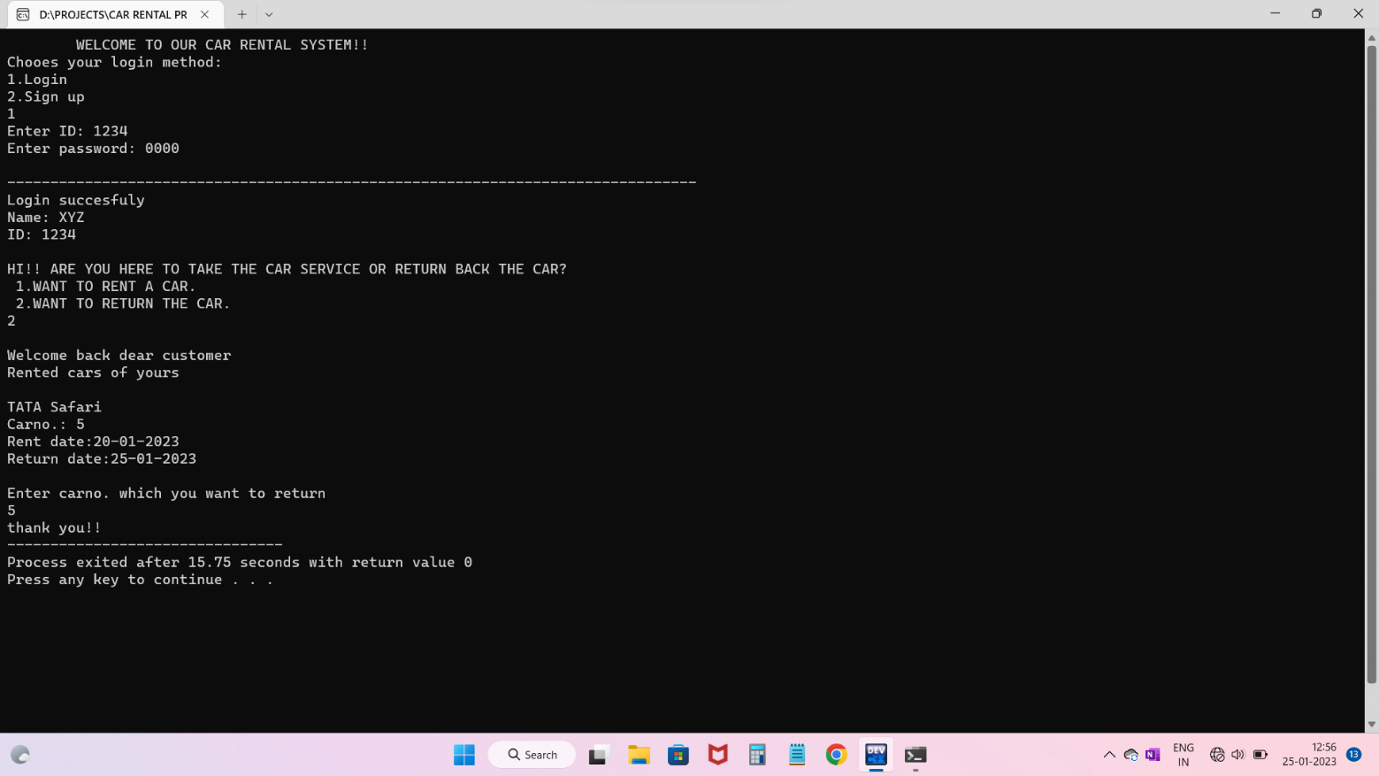

REFERENCE:

* https://cboard.cprogramming.com/c-programming/149266-car-rental-program.html
* <https://www.studytonight.com/c-projects/>
* https://youtu.be/irqbmMNs2Bo

THANK YOU